AWS Task-3
Task Description:

- Create a S3 bucket, with no public access and upload files to the bucket & view the logs using cloudwatch for the uploaded files.

Creation of S3 bucket
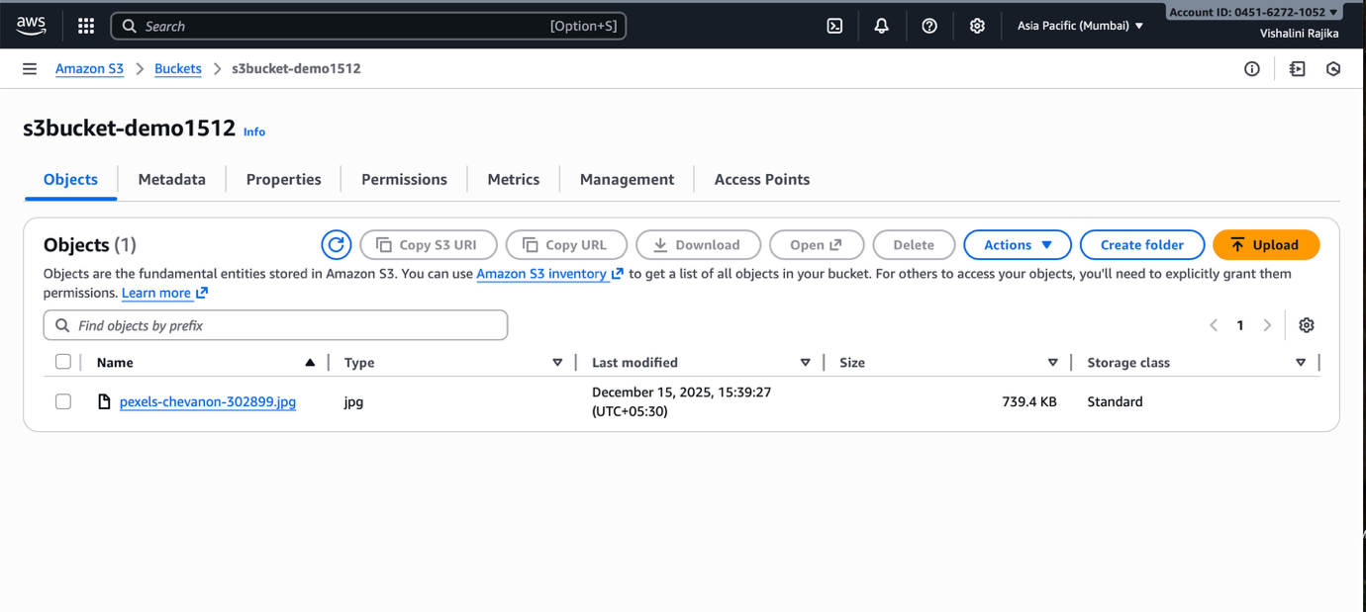
Created Cloud trail for logging the events
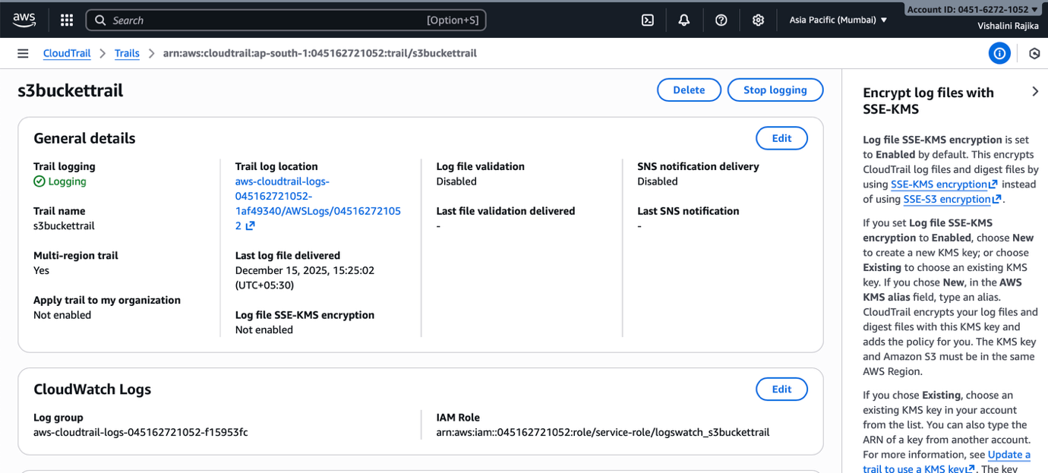

Logs viewed using Cloud watch
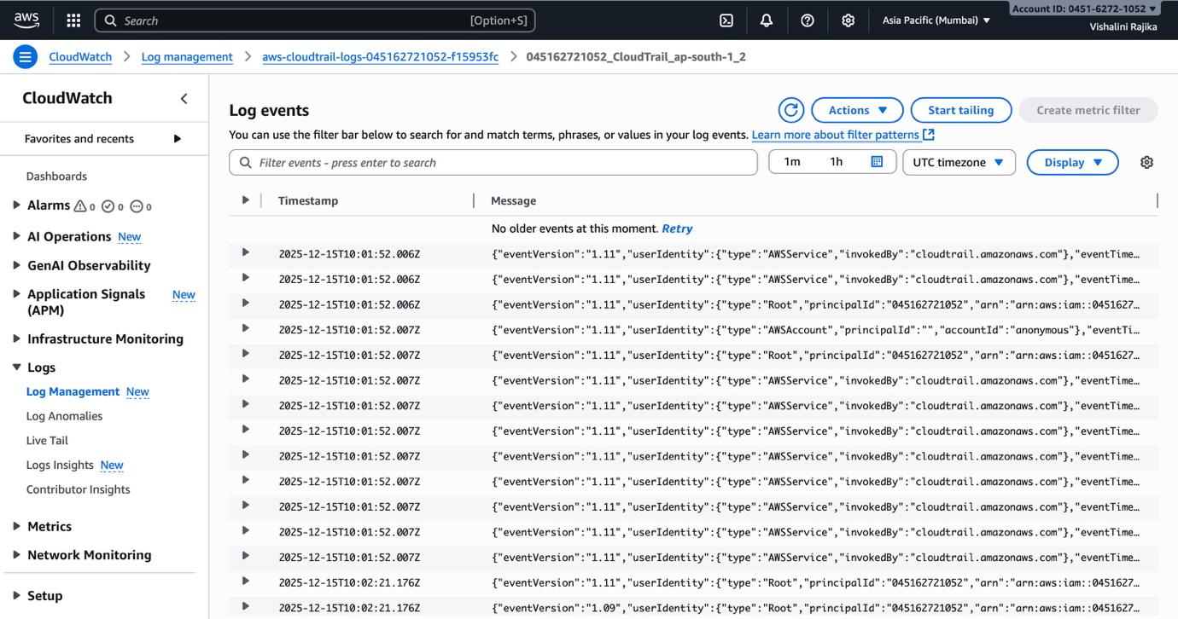

- Launch two ec2-instances and connect it to a application load balancer, where the output traffic from the server must be an load balancer IP address

Launched 2 EC2 instances

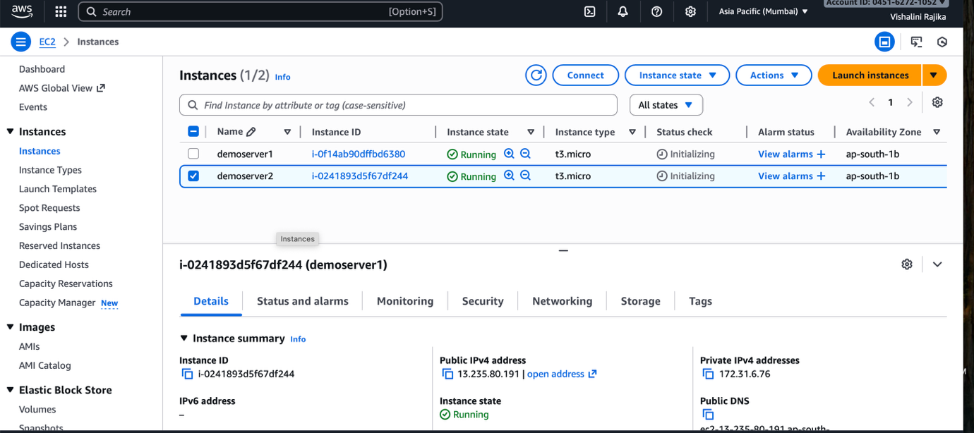
Connect it to the Application Load balancer the output traffic from the server must be an load balanacer IP address
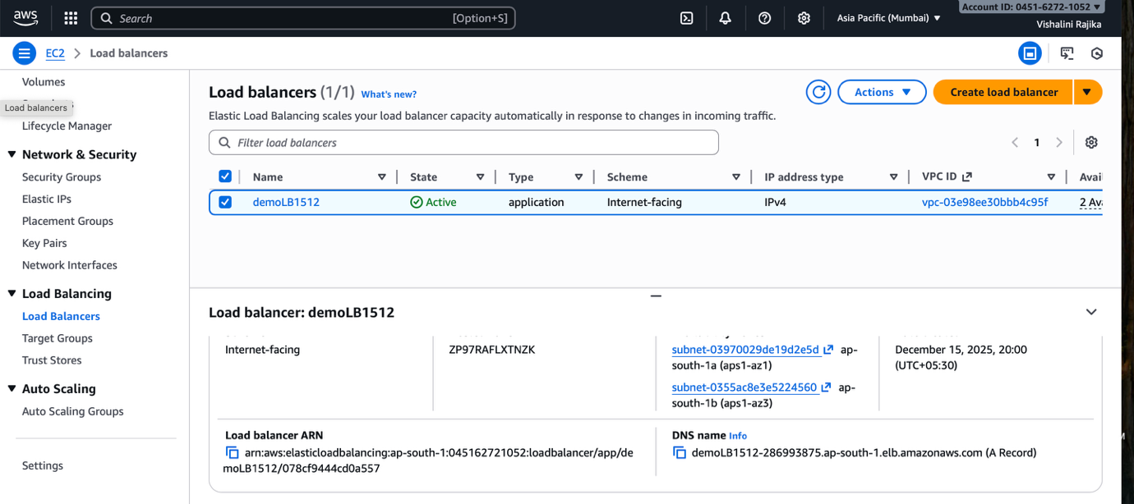
Output:
